Bubble Breaker Game Design by Aniol Santacreu

Introduction

The following is Aniol Santacreu’s proposal for a puzzle game, playable on Android and iOS systems. Bubble Breaker’s a famous game popularized with Pocket PC’ Jawbreaker but that nowadays lacks a proper version.

Game Design

Overview

http://www.wow.com/wiki/Samegame

Bubble Breaker is a puzzle game wherein a player must select a group of bubbles on a grid and click to destroy them. The grid fills the screen with bubbles of N colours. The more bubbles the player destroys with a single click, the higher the score will be.

The game finished when no more moves are available and the main objective is to beat the high score.

The entire game encourages deep thinking and strategy instead of fast paced action.

Bubble Breaker will support up to four game modes: Standard, Continuous, Shifter and Mega Shifter.

The art of the game will be retro as a tribute of its ancestor. But as the development advances, the theme of bubbles may vary.

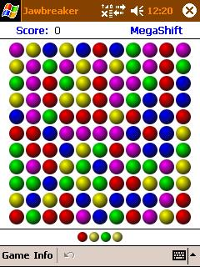

Gameplay and Game Modes

The game consists of a game board of differently coloured bubbles arranged in matrix. There are five different colours, red, blue, green, yellow and purple. The player then clicks on any group of connecting similarly-coloured bubbles to eliminate them from the matrix, earning an appropriate number of points in the process. The first click will highlight the group and show the score, and with the second click, the group will pop.

The game ends when the player has no more moves left. The screen immediately goes to the scoring screen, where statistics can be seen, along with a button to restart the game.

Standard

The standard mode is described above

Continuous

The continuous mode is similar to the standard mode, with one major difference. Whenever the player clears an entire column of bubbles, a new one arrives from the left side of the game board. New columns can be previewed in a small area at the bottom of the screen.

Mega Shift

This mode is similar with the continuous mode. The major difference is that the bubbles will always move to the right of the screen if there is space for them to do so.

Shifter

This mode is similar with the standard mode. The major difference is that the bubbles will always move to the right of the screen if there is space for them to do so.

Score

The scoring can be expressed in the formula “Y=X(X-1)”. X represents the number of balls grouped together, Y the resulting score.